This laboratory assignment accompanies the book, [*Embedded Systems: Real-Time Interfacing to ARM Cortex M Microcontrollers, ISBN-13: 978-1463590154*](https://www.amazon.com/Embedded-Systems-Real-Time-Interfacing-Microcontrollers/dp/1463590156), by Jonathan W. Valvano, copyright © 2021.

## Goals

* Implement a “smart object” that connects to a phone application ([Blynk](https://www.blynk.cc/)) via a cloud based server using the [ESP8266 **WiFi**](https://www.espressif.com/en/products/hardware/esp8266ex/overview) module connected to the TM4C123. (Fig 4.1)
* Remotely control the alarm clock developed in Lab 3 via the “[Blynk Virtual Pin](http://docs.blynk.cc/#blynk-main-operations-virtual-pins)” interface.
  + - Replace the manual switches from Lab 3 with Virtual Pin (VP) Switches.
* Remotely read the Hour/Minutes/Seconds via the “Blynk Virtual Pin” interface. Display the data on the Blynk App.
* **Extra Credit**: Remotely read any sensor and via the “Blynk Virtual Pin” interface. Display the data on the Blynk App. Reading a sensor and displaying its value is an extra credit component.

## Team Size: 2

*Figure 4.1: Lab 4D Block Diagram*

## Review

* Valvano Section 11.4 on internet of things and this web page: [Internet Of Things](http://users.ece.utexas.edu/~valvano/Volume1/E-Book/C16_InternetOfThings.htm)
* [Getting started with the Blynk Application](http://docs.blynk.cc/#intro)
* [Programming environment for the ESP8266](http://users.ece.utexas.edu/~valvano/EE445L/SetupESP8266ProgrammingEnvironment.htm)
* [Arduino programming](https://playground.arduino.cc/uploads/Main/arduino_notebook_v1-1.pdf)

## Starter Project

Use the [**Lab4_Blynk_4C123**](https://www.dropbox.com/sh/3zfinjkhdahit6c/AAB0X6ZNjROjg7VlTPXxGfD8a?dl=1) starter project starter project from the original class installation (do not look at ESP8266_4C123 or ESP8266v2_4C123 projects). Make sure you can compile this code before editing. Review this example project looking for the virtual pins used to communicate between LaunchPad and the Blynk app on your phone. In the procedure section you will merge your Lab 3 code into this Lab4D project. However, you should run the existing project before merging your Lab 3 code, so that you can debug the hardware and Blynk application separately from your software. The original source code (Arduino based) is located [**here**](https://www.dropbox.com/sh/ojl8jfv0udfzdnc/AAAu6KFbrYvLShPHfptopmZGa?dl=1)

## Image result for esp8266 pictureBackground

**WiFi** is the name given to devices that communicate wirelessly employing the IEEE 802.11 standard. They typically operate in the 2.4 GHz Industrial-Scientific-Medical (ISM) unlicensed band that is shared with ZigBee (IEEE 802.15.4) and Bluetooth (IEEE 802.15.1) communications. The IEEE 802.11 standard describes how information is represented via radio frequency signals, i.e., the **physical** or **PHY** layer, and how communications are formatted and controlled, i.e*.*, the **media access control** or **MAC** layer. Communication requirements beyond the PHY and MAC, e.g*.*, flow control, error recovery, and routing, are handled at higher levels of the internet stack.

*Figure 4.2: The ESP8266 WiFi module.*

## Required Hardware:

[ESP8266](https://www.amazon.com/Makerfocus-ESP8266-Wireless-Transceiver-Compatible/dp/B01EA3UJJ4/ref=pd_day0_hl_60_1?_encoding=UTF8&pd_rd_i=B01EA3UJJ4&pd_rd_r=bcbd5991-6f51-11e8-8490-8f50b5c91b8a&pd_rd_w=lfVkU&pd_rd_wg=QkF1z&pf_rd_i=desktop-dp-sims&pf_rd_m=ATVPDKIKX0DER&pf_rd_p=4014010564823900592&pf_rd_r=HFMNZTD3NJCQ1VA0X9EC&pf_rd_s=desktop-dp-sims&pf_rd_t=40701&psc=1&refRID=HFMNZTD3NJCQ1VA0X9EC) and ESP adapter WiFi Module (from TA) $3.50

[ST7735](https://www.adafruit.com/product/358) LCD Module (yours) $19.99

[EK-TM4C123GXL](http://www.ti.com/tool/EK-TM4C123GXL#buy) Tiva LaunchPad (yours) $12.99

Any analog sensor You find it (optional)

[LM2937-3.3](http://www.ti.com/product/LM2937-3.3) and two 4.7uF tantalum 3.3V regulator (from EER checkout) $ 1.68

## Specifications

This lab will create a “smart object” that connects to your smart phone via the [Blynk](https://www.blynk.cc/) application. Your system includes

* A PC, running [PuTTY](https://www.putty.org/), connected to the TM4C123 through UART0 (strongly suggested for debugging)
* A TM4C123 LaunchPad running your software
* An ESP8266 WiFi module that is configured with the Blynk ESP8266 WiFi code.
* A ST7735R or any LCD showing the time
* Use Lab 2 code to record incoming messages and outgoing jitter.
* The minimum requirements are to be able to set time, ~~set alarm,~~ and visualize the time from the phone. There must be at least 3 displays (hour, minute, second) and 3 buttons.
* Measure an external sensor using the ADC (extra credit). Any external sensor and any interface method is ok (ADC, I2C, or SPI).

**NOTE: You will need access to a wireless access point, configured with or without security.**

You are free to define the “look and feel” of your system as long as you meet the specifications listed above. Feel free to write your code using the style found in TivaWare or the book.

## Interfaces

The TM4C123 system clock will be 80 MHz. The PC (via [PuTTY](https://www.putty.org/)) is connected to the LaunchPad via UART0, which is embedded in the standard USB debugging cable. This link is used for debugging. The starter code uses 115200 bits/sec, 1 stop, no parity, and no flow control. There are two #defines in esp8266.h you can select either one, the other, both or neither of the UART0 or the ST7735 LCD for debugging. DEBUG1 activates UART0 debugging and DEBUG3 actives ST7735 debugging. Use the Windows device manager to determine the COM port used to communication communicate with your LaunchPad (in Device Manager, click View -> Show hidden devices to view COM ports). The interface between the ESP8266/ST7735 and the LaunchPad is shown below in Figures 4.3, 4.4, 4.5 and Table 4.1. The ESP8266 interface uses GPIO and UART ports on the LaunchPad. The ESP8266 interface uses UART5 running at 9600 bits/sec, 1 stop, no parity, and no flow control.

Note: There are two different pinout numbering schemes for the ESP8266. The schematic in Figure 4.4 below uses the pinout numbering in 4.3(B) below

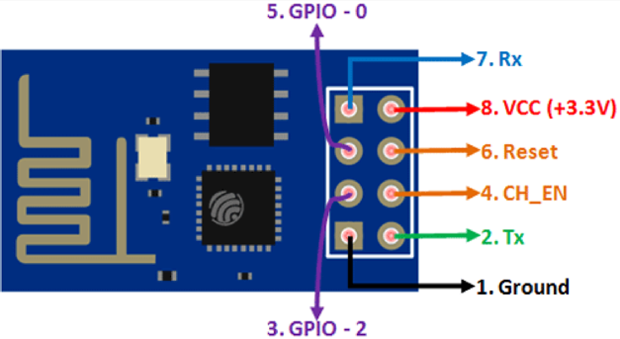



(A) (B)

*Figure 4.3: ESP 8266 Pinout numbering*

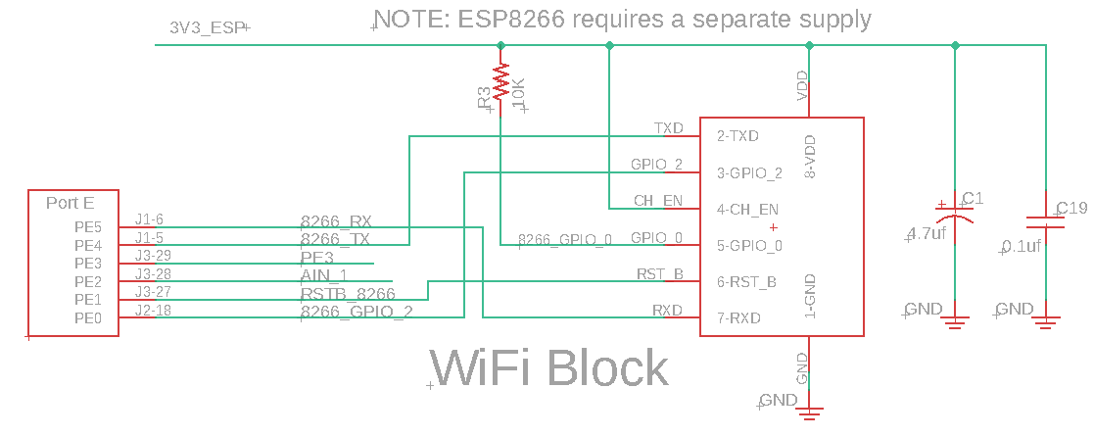

*Figure 4.4: Detailed schematic of the ESP8266 interface. UART5 is used. The +3V3 supply for the ESP8266 is different from the regular LaunchPad +3.3V, see Figure 4.6.*

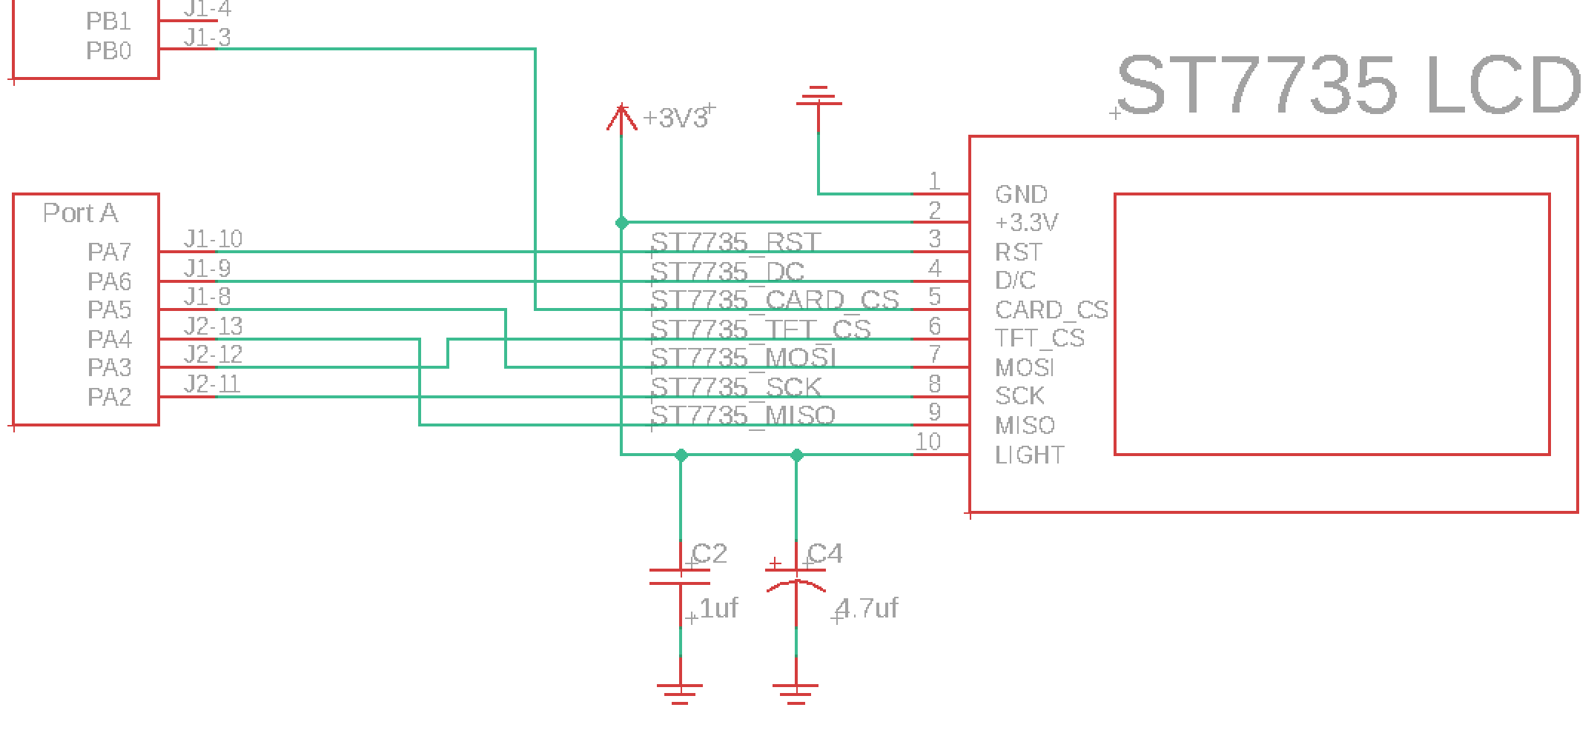

*Figure 4.5: Detailed schematic of the ST7735 interface. The CARD_CS pin (pin 5) on the LCD is optional and needed only when the SDC card is being used. This 3.3V supply is the regular LaunchPad 3.3V.*

Pin Signal Direction Pin Signal Direction

P1.1 3.3 VCC Power P2.1 Gnd GND Power

P1.2 PB5 UNUSED NA P2.2 PB2 UNUSED NA

P1.3 PB0 CARD_CS OUT P2.3 PE0 ESP_RDY IN

P1.4 PB1 UNUSED NA P2.4 PF0 SWITCH IN

P1.5 PE4 UNUSED NA P2.5 Reset nRESET IN

P1.6 PE5 ESP_U5TX OUT P2.6 PB7 UNUSED NA

P1.7 PB4 ESP_U5RX IN P2.7 PB6 UNUSED NA

P1.8 PA5 TFT_MOSI OUT P2.8 PA4 TFT_MISO IN

P1.9 PA6 TFT_DC OUT P2.9 PA3 TFT_CS OUT

P1.10 PA7 TFT_RST OUT P2.10 PA2 TFT_SCK OUT

Pin Signal Direction Pin Signal Direction

P3.1 +5 +5 V Power P4.1 PF2 LED OUT

P3.2 Gnd GND Power P4.2 PF3 LED OUT

P3.3 PD0 TMP36_IN IN P4.3 PB3 UNUSED NA

P3.4 PD1 UNUSED NA P4.4 PC4 UNUSED NA

P3.5 PD2 UNUSED NA P4.5 PC5 UNUSED NA

P3.6 PD3 UNUSED NA P4.6 PC6 UNUSED NA

P3.7 PE1 ESP_RSTB OUT P4.7 PC7 UNUSED NA

P3.8 PE2 UNUSED NA P4.8 PD6 UNUSED NA

P3.9 PE3 Debug OUT P4.9 PD7 UNUSED NA

P3.10 PF1 LED OUT P4.10 PF4 SWITCH IN

Table 4.1. ESP8266, ST7735 and TMP36 connections to the TM4C123 LaunchPad.

You could use PE3 for profiling the interface. The Port F LEDs and switches are used in the starter code, but you can repurpose these pins as needed for your Lab 4.

## How to power the system

The ESP8266 draws too much current to be run off the 3.3V regulator on the LaunchPad. To supply 3.3V to the ESP8266, you must build a separate 3.3V regulator using the LM2937ET-3.3 linear regulator and two 4.7 uF tantalum capacitors (see Figure 9.2 in the book, with Vin=5.0V and both capacitors 4.7 uF). **NOTE: You must connect all the grounds together.**

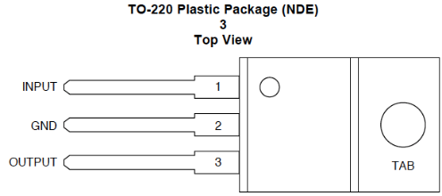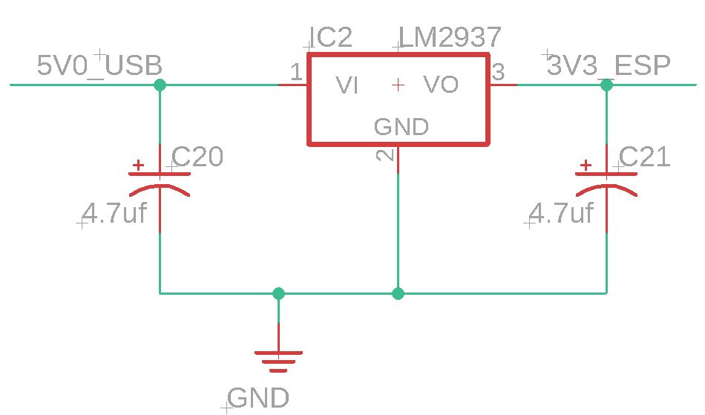

*Figure 4.6: Regulator circuit using the LM2937 linear regulator. Please test this circuit before attaching to ESP8266.*

## Preparation

**Part a**) Download the Blynk (legacy) App to your Smart Phone (iPhone or Android), see Figure 4.7. In order to connect the Blynk App to the TM4C123, you need an **Auth Token**. Follow this sequence to obtain the token:

1. Create a new account in the Blynk Application (you do not need to spend money)
2. Create a New Project
3. Choose the ESP8266 board and connection (wifi) you will use. After the project is created, you will receive the **Auth Token** via the Blynk website. Place this token in line 34 of esp8266.c.
4. You can also observe the **Auth Token** in the Blynk App

Build a Blynk app with one Button on VP1 (sends 0 or 1 to the TM4C123) and one Display on VP74 (displays a decimal number

**  **

*Figure 4.7: Install the Developer Blynk App (not Blynk IoT new) and create two VPs.*

**Part b**) Use the **Lab4_Blynk_4C123** starter project from the original class installation. Download the following code examples:

1. Optional: Arduino IDE ESP8266 WiFi configuration code from [**here**](https://www.dropbox.com/sh/ojl8jfv0udfzdnc/AAAu6KFbrYvLShPHfptopmZGa?dl=1)
2. Optional: Arduino example code from [**here**](https://www.dropbox.com/sh/ojl8jfv0udfzdnc/AAAu6KFbrYvLShPHfptopmZGa?dl=1)

The **Lab4_Blynk_4C123** starter project contains the following modules:

* ESP8266 is a low level UART5 interface to the ESP8266-ESP01 (interrupt driven)
* UART is an interface to PC for debugging (interrupt driven)
* ST7735 is an interface to the LCD, used for debugging
* Timer2 is a periodic interrupt to handle receiving data from Blynk
* Timer3 is a periodic interrupt to handle sending data to Blynk
* PLL is used to set the bus clock to 80 MHz
* PortF is a simple driver for the switches and LEDs on the LaunchPad

Add your Lab 2 **Dump.c** to the project and modify **Blynk_to_TM4C** to capture incoming data like this

**LED = pin_int;**

**Dump_Capture(LED); // add this line**

**PortF_Output(LED<<2); // Blue LED**

Modify **SendInformation** to measure jitter like this

**uint32_t thisF;**

**Jitter_Measure(); // add this line**

**thisF = PortF_Input();**

Add calls to the corresponding initialization functions before interrupts are enabled.

**Part c**) Collect all the hardware needed to perform this lab: LaunchPad, ST7735, ESP8266-ESP01 (you can keep the ESP8266-ESP01 for Lab 10 and your project), 8-pin to 8-pin adapter so the ESP8266 can be plugged into the breadboard (please give this adapter back after Lab 10).

**Part d**) You will need to modify the following lines of code in esp8266.c with the correct values. You will find these three lines around line 34. The existing **ssid** and **pass** parameters in the starter project can be used to access a special hot spot in the EE445L lab. See below for the current login parameters. There is another special hot spot in the Longhorn Maker Studio.

char ssid[32] = "hotspot_ssid";

char pass[32] = "hotspot_password";

char auth[64] = "your_Blynk_authorization_code";

EER 1.806 South Tower Router IP: 10.157.130.76

SSID: EE-IOT-Platform-03 Password: g!TyA>hR2JTy

## Procedure: Power the devices

**Step 0:** As always, one must turn off the power while connecting or disconnecting wires to the LaunchPad. So, please connect the wires as shown in Figures 4.4 and 4.5 first, before powering.

**Step 1:**  Build and test the 3.3V regulator circuit shown in Figure 4.6 before connecting this 3.3V output to the ESP8266. Place a current meter between the regulator output and the ESP8266 power input.

**Step 2**: The power to the LaunchPad and ST7735R will be derived from the USB cable connected to the LaunchPad. Note that you will NOT remove the jumper from the LaunchPad (removing the jumper would remove power to the TM4C123, and nobody wants that). The 3.3V output of the regulator is ONLY used to power the ESP8266 (and not connected to the LaunchPad 3.3V).

**Step 3:** Turn on the LaunchPad and verify 3.3V on the LaunchPad and 3.3V to the ESP8266. Debug the software as needed.

## Procedure: Run the Starter Blynk

**Step 1:** You will need to debug the ESP8266 code with a WiFi access point for which you know the SSID and password. First verify the hardware configuration is operational by initializing the ESP8266 and **monitoring the diagnostic messages** using PuTTY to confirm that the connection to the BLYNK server was successful. You should see the following debug messages from the ESP8266 if the connection was successful.

SSID: <your SSID>

Password: <your Password>

Auth: <your AUTH code>

.........................................

WiFi connected

IP address: aaa.bbb.ccc.ddd

Waiting for connection the Blynk server

Connected to Blynk server

Leaving Setup_Wifi

**Step 2:** Use the Blynk app with one button VP1 (from phone to LaunchPad) and one numerical output VP74 (LaunchPad to phone). You should be able to turn the blue LED on and off from the phone using VP1. You should be able to see the status of the two switches on your phone using VP74.

***Deliverable 1***: Take screenshots in the debugger showing incoming data dumps, and jitter measurements, collected using your Lab 2 **dump.c** code.

## Procedure: Bring up Alarm Clock Code

**Step 1)** Merge your Lab 3 into this project. You will choose virtual pins 1, 2, 3,… for parameters you wish to send from the phone to the clock, and you will use virtual pins 70, 71, 72… for parameters you wish to send from the TM4C123 to the phone.

There are two key rules when interfacing to the ESP8266:

1. There are 16 Virtual Pins that send data from the Blynk Application to the TM4C (V0-V15).
2. There are 30 Virtual Pins (V70-V99) that send data from the TM4C to the Blynk Application.

**NOTE**: These numbers can be changed by reprogramming the ESP8266. The ESP8266 is programmed using the Arduino IDE. You will need to check out a special programmer to reprogram the ESP8266.

**Step 2**) Now it is time to setup the Blynk application palette on your phone. There are a number of different mechanisms to implement the clock control function. The following figures are a suggestion and not a requirement. The minimum requirements are to be able to set time, set alarm, and visualize the time.

This is one way:

Add 5 button switches to the palette: Setup each button as a momentary switch:

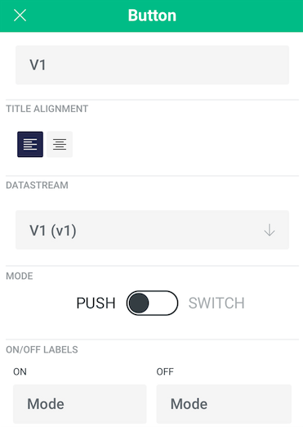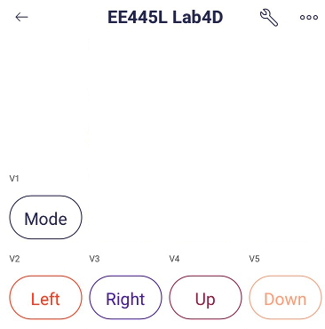

In this example we are using Virtual Pins V1 to V5

These five virtual switches replace the physical switches connected to the TM4C. You can “wire OR” the physical switches with the Virtual Pins if you want.

Now we need to setup the 6 Step Switches

that will control the Hour/Minutes/Seconds directly: Setup each Step Switch as so:

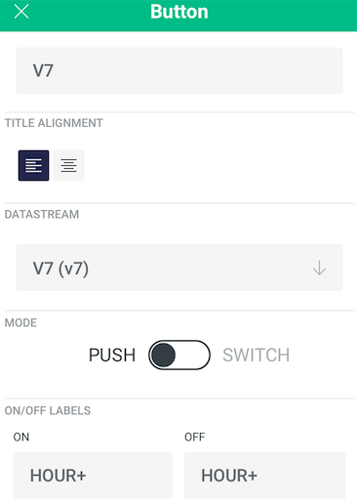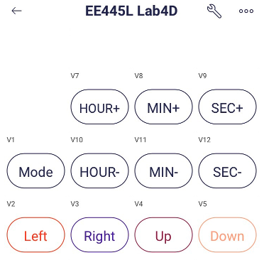

In this example we are using Virtual Pins: V7 to V12 Setup each display with the correct limits.

The next thing to setup is the Hour/Minute/Second

display on the palette:

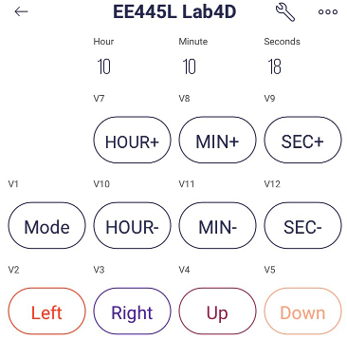

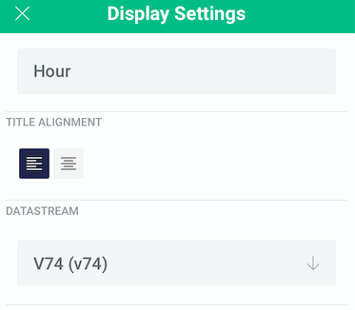

In this example we are using virtual pins V74 to V76 to display Hour, Minutes and Seconds.

**Step 3:** The next step is to test the ESP8266, TM4C, phone system. Figure 4.6 shows the dataflow diagram between the WiFI module and the “Smart Object”.



*Figure 4.8: ESP8266 ⇔ TM4C Dataflow Diagram*

**Step 4 (extra credit):** Interface a sensor and use the ADC to measure the signal. Calibrate the sensor so it reads data in a human understandable fashion. One possibility uses the TMP36 to read temperature. The TMP36. The datasheet for the TMP36 is located at: [ADI_TMP36](http://www.analog.com/media/en/technical-documentation/data-sheets/TMP35_36_37.pdf). You will have to determine how to convert the output voltage from the TMP36 to °F and °C. These values will be sent on virtual pins V70 to V99 to the Blynk App. Another possibility is the slide-pot from EE319K.

***Deliverable 2***: Take at least three screenshots on the phone illustrating the features of your system.

## Procedure: Measure the current

**Step 1a (in Lab):** Disconnect the USB cable to the PC. If you have access to the lab bench supply, you can adjust the voltage output to +5V and connect it to VBUS on the LaunchPad. Verify 3.3V on the LaunchPad and 3.3V on the ESP8266. Notice between 40 and 200 mA of current on the 5V line, depending on what hardware you have connected and which software you are running. Take current measurements (both on 5V and on 3.3V to ESP8266) with 1) just the clock; 2) alarm on; and 3) during wifi communication.

**Step 1b (outside of Lab):** Disconnect the USB cable to the PC. If you do NOT have access to the lab bench supply, you will remove the 2-pin jumper from the LaunchPad and connect a current meter between the pins. Reconnect the USB cable to the PC. Verify 3.3V on the LaunchPad and 3.3V on the ESP8266. Notice between 40 and 200 mA of current on the 5V line, depending on what hardware you have connected and which software you are running. Take current measurements (both on 5V and on 3.3V to ESP8266) with 1) just the clock; 2) alarm on; and 3) during wifi communication. If you only have one current meter you can perform the experiment twice repeating the same conditions.

**Step 2:** Turn off power and remove the current meter(s). Connect the regulator output to the ESP8266 supply. Make sure the 2-pin jumper on the LaunchPad is conn and verify the regulator still works using a voltage measurement on the ESP8266 3.3V supply.

***Deliverable 3***: Document how you measured currents and report the current values (5V total and 3.3V to ESP8266) for 1) just the clock; 2) alarm on; and 3) during wifi.

## Deliverables (exact components of the lab report)

1. Objectives (1/2 page maximum)
2. Hardware Design (only if needed for the extra credit sensor)
3. Software Design
4. Deliverables 1, 2, 3
5. Read this tutorial on the [Internet Of Things](http://users.ece.utexas.edu/~valvano/Volume1/E-Book/C16_InternetOfThings.htm) and do an analysis and discussion (1 page maximum) on the following topics:

* In the client server paradigm, explain the sequence of internet communications sent from client to server and from server to client as the client saves data on the server. Assume the client already is connected to the WiFi AP and the client knows the IP address of the server.
* What is the purpose of the DNS?
* What is the difference between UDP and TCP communication? More specifically when should we use UDP and when should we use TCP?

## Checkout

Demonstrate that your system can control the Clock on the TM4C display data using the Blynk Application. Demonstrate that your system can read the sensor (extra credit) and time on the TM4C. Upload your software as instructed by your TA.

## Setting up the templates for the Blynk application:

1) Setup an account on Blynk: <https://docs.blynk.io/en/getting-started/signup>

2) Once you are signed in, setup developer mode: <https://docs.blynk.io/en/getting-started/developer-mode>

You will then be able to develop templates for Lab 4D and Lab 10F.

3) Go to the “Template Quick Setup”: <https://docs.blynk.io/en/getting-started/template-quick-setup> Read the tutorial on how to create and edit templates. Note: you do not need to configure the ESP8266. That has already been done.

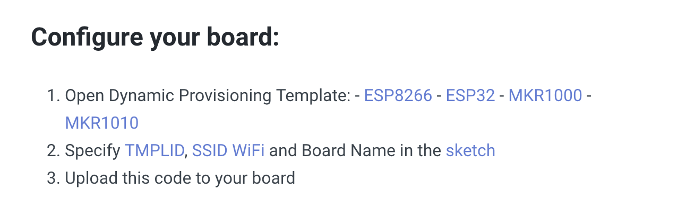

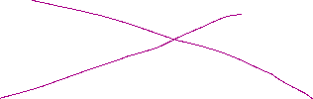

4) Go to the next section on setting up DataStreams:

<https://docs.blynk.io/en/getting-started/template-quick-setup/set-up-datastreams>

Once you have read the tutorial go the dashboard: <https://blynk.cloud/dashboard/>

5) Select “New Template”

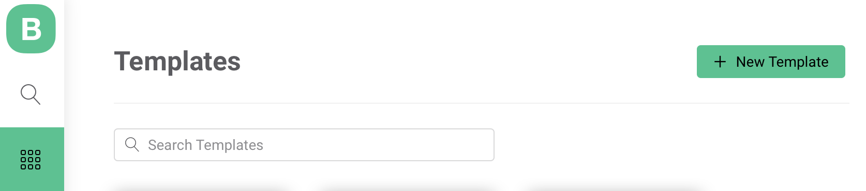



Select a name for the template:

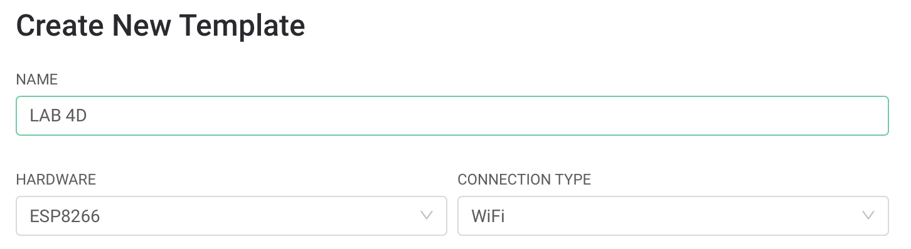



Once the template has been created you will need to define the Virtual Pins (VP) that you will use in your template. Select Lab 4D template:

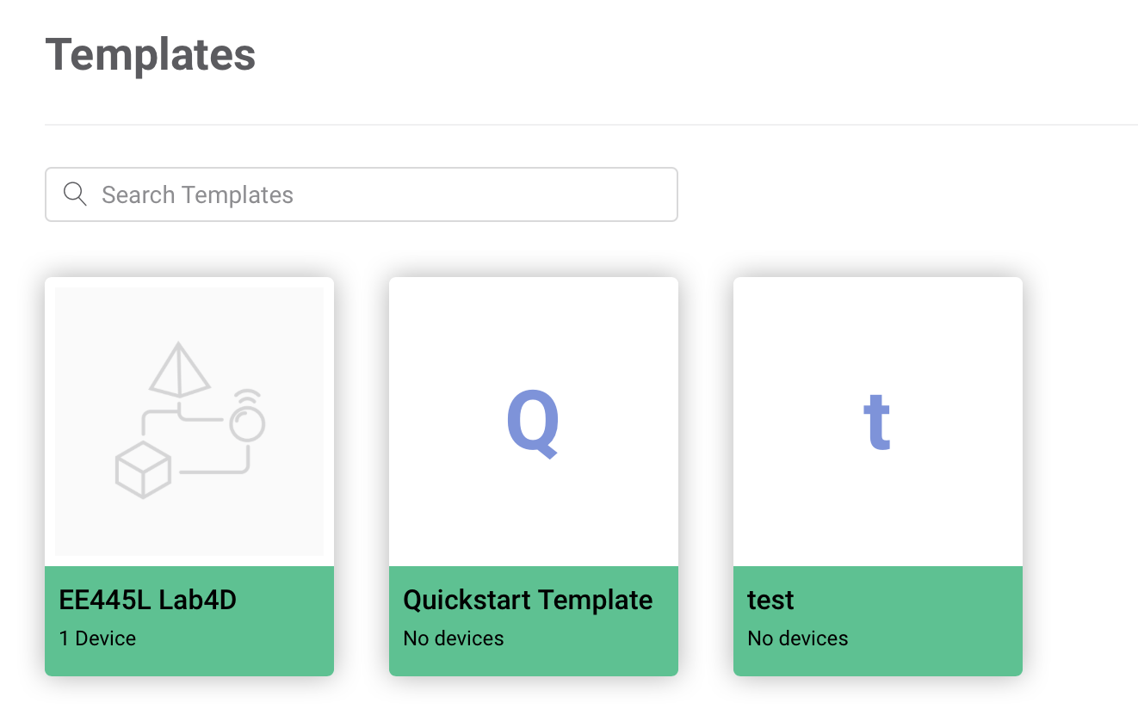

The following window will appear. Select DataStreams.

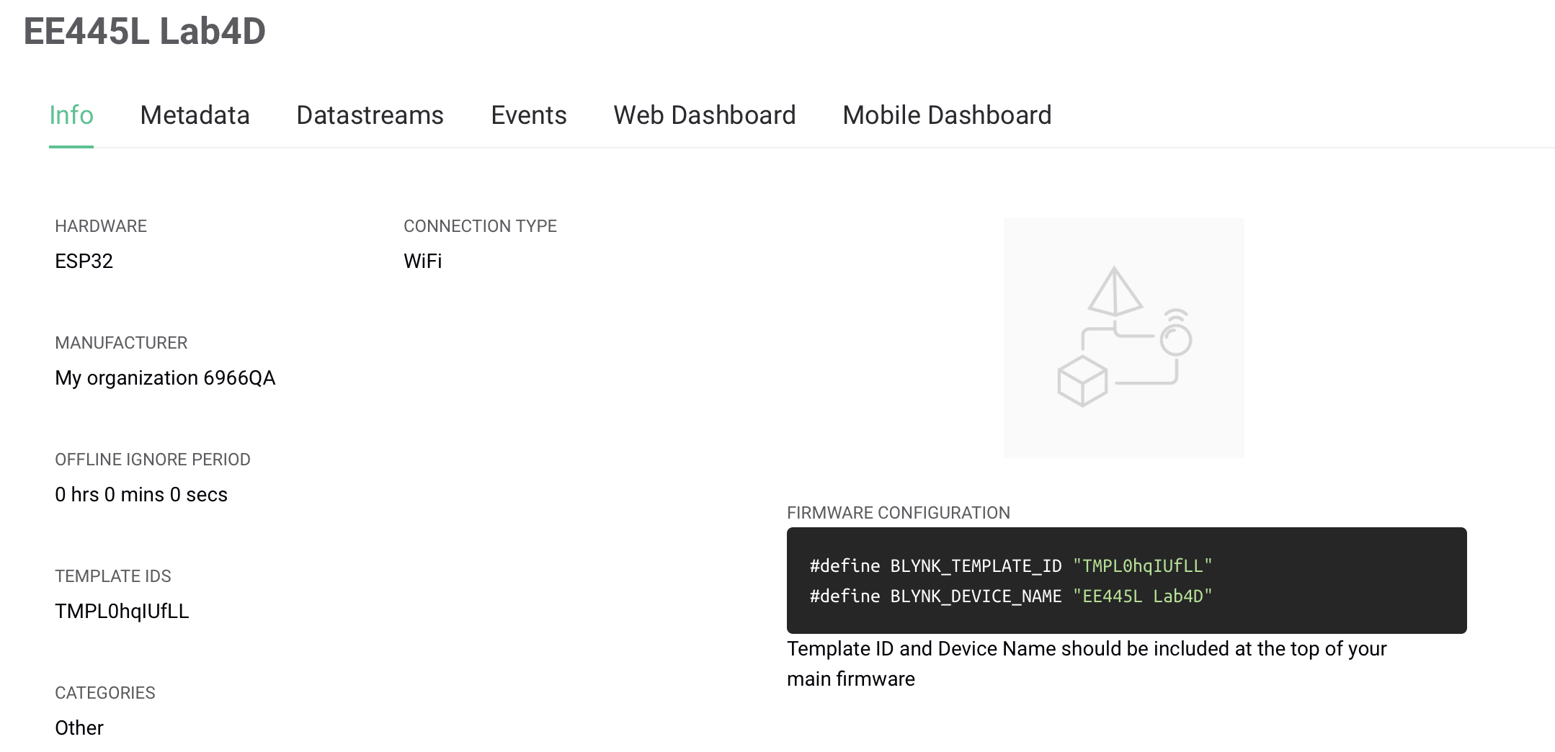



This will take you to the VP setup page:

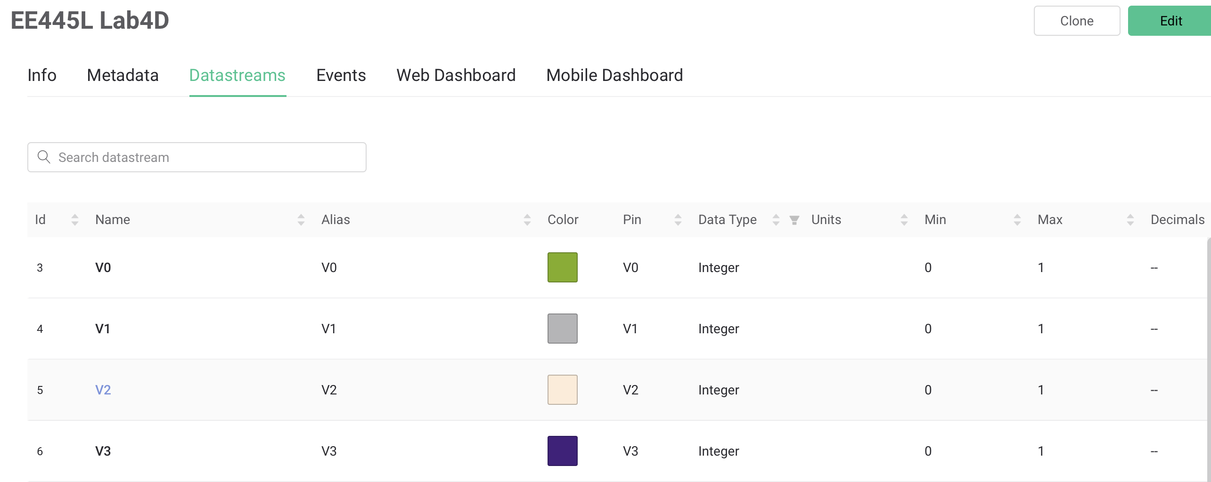

Follow the tutorial on setting up a VP. You will need to generate an entry for every VP you will be using in your design. Once the VPs have been entered, go back to Main dashboard, and select “Search”

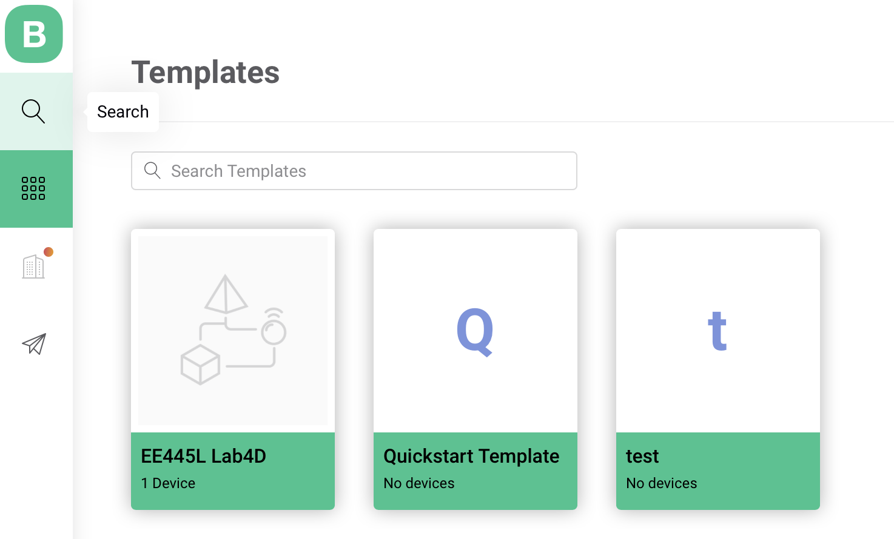



This will take you to window where you will setup a device using the template you just built. Select New Device

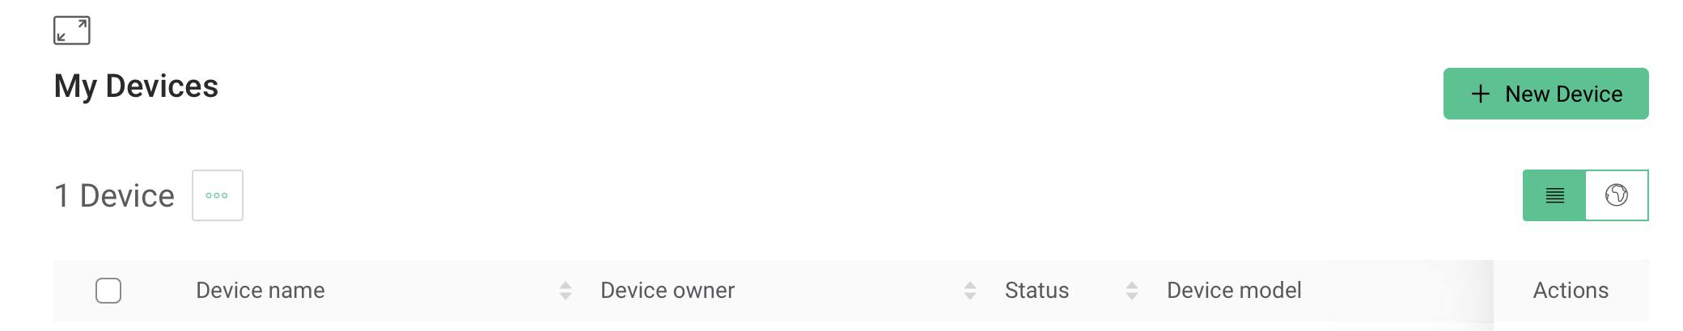



Select “From Template”

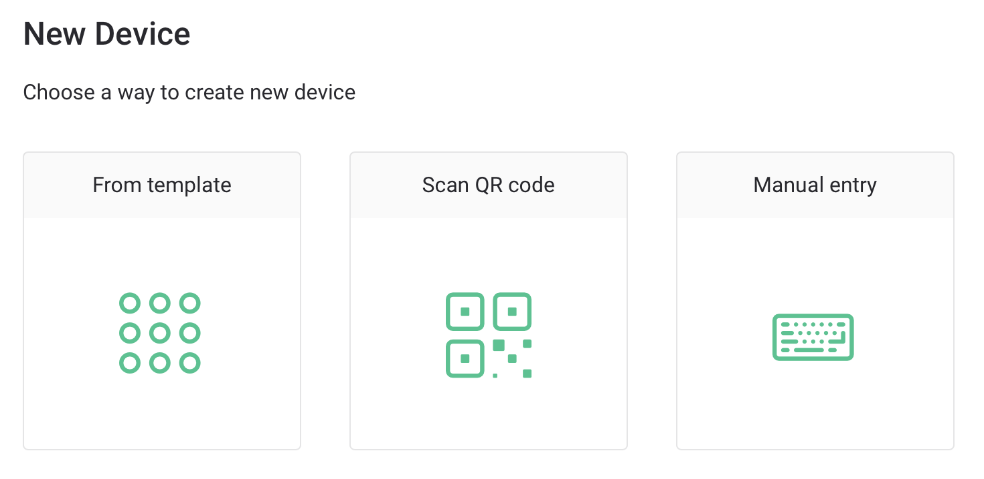



Select the Lab 4D template then “Create”

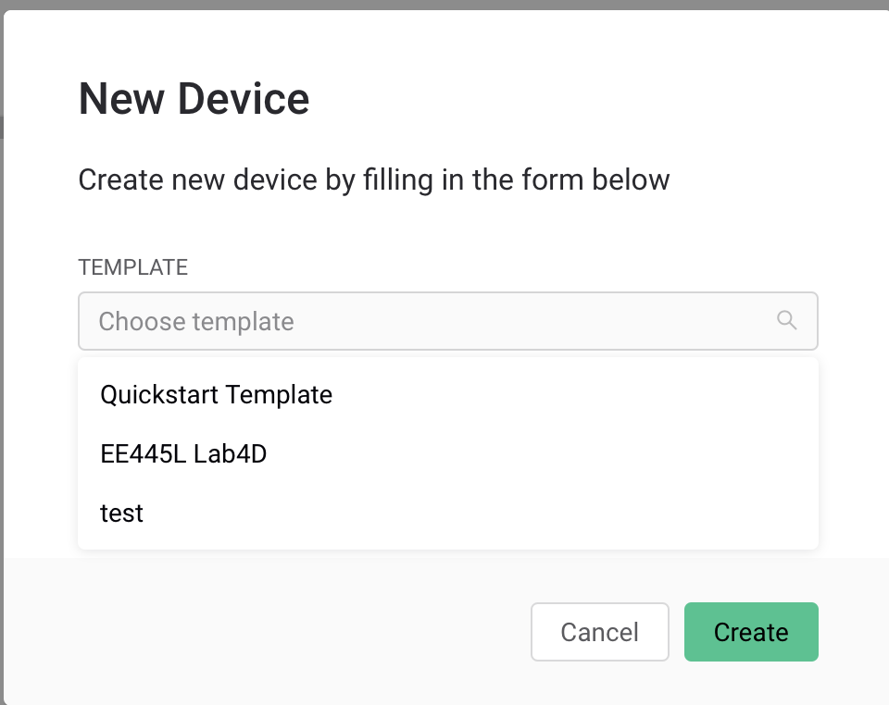



The new device will show up in the table.

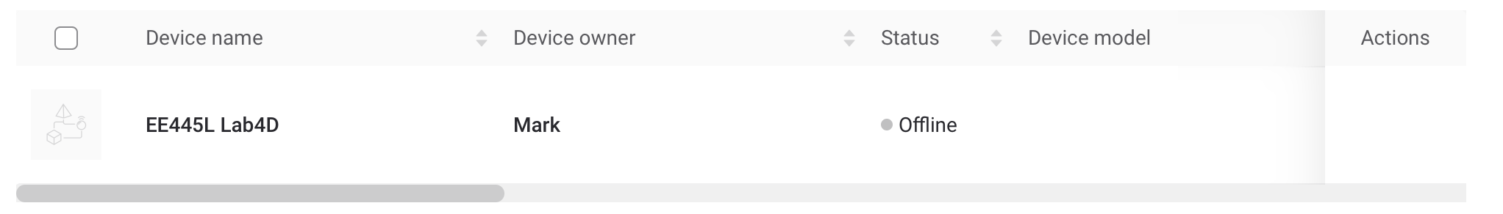

At this point you will be able edit the palette on your phone as described above.